LOWVILLE BAPTIST CHURCH
7627 N. STATE ST.
PO BOX 89
LOWVILLE, NY 13367
315-376-2115
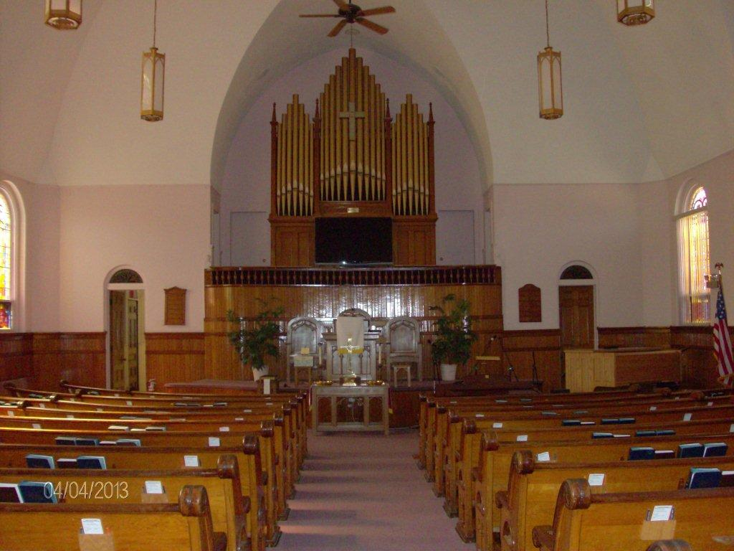
Website: www.lowvillebaptistchurch.org
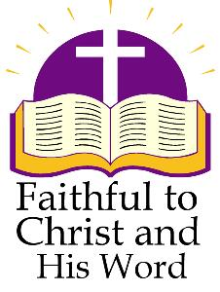
GROW IN FAITH - GROW SPIRITUALLY - REACH THE LOST
LOWVILLE BAPTIST CHURCH

PURPOSE

Knowing that our world is full of people who long for a meaningful spiritual life and strong connection with God, Lowville Baptist Church is committed to assist those who daily seek to make Jesus the Lord of their lives. The church will maintain regular public worship, develop Christian character and encourage evangelistic activity. Lowville Baptist Church will subscribe to the complete Old and New Testaments of the Holy Bible as the basis of faith and practice.

VISION

Within the next four years, Lowville Baptist Church will demonstrate significant spiritual growth by being actively involved in Bible study, by openly taking petitions to the Lord in prayer, and by seeking ways to reach out to the unsaved.

MISSION

Lowville Baptist Church seeks to be a congregation of believers who value coming together for public worship, experiencing the joy of being in God’s presence, and obeying His leading for using our gifts in this world. This entails inviting people into our church who are searching for a meaningful spiritual life.
It means assisting each other to grow in faith through depth of prayer, building through skills of discernment, and through receiving quality direction from the reading and study of scripture. We place a priority on developing discipline in believers who are energized to minister beyond the boundaries of the church building.

LOWVILLE BAPTIST CHURCH HISTORY

The First Baptist Church of Lowville and Denmark was formed in 1819. The church was built that year on State Road and because it sat on the line separating the Town of Lowville and the Town of Denmark, it was locally known as the Line Church. On September 8, 1824, thirty-two members who lived in and close to Lowville met and, with advice from First Baptist Church of Lowville and Denmark, formed the Lowville Baptist Church.
To raise money for the new church building, ‘seats’ were sold for $1,967 apiece. By November 1825, fifty-six seats had been sold and a house for worship was built in Lowville. The first record of mission giving is May 1829, when a five year commitment was made to help print the scriptures in Burmese. In 1832 the first Sunday Schools were begun, one on the West Road and one in the Village.
The present church on North State Street was built in 1890. A Christian Education wing was completed in 1965. The Fellowship Hall addition was completed in 1997. The church has always held the condition of the building a priority and many repairs and beautification projects have been undertaken and continue to be worked on.
The local community of Number Four enjoyed being a branch of the Lowville Baptist Church from 1835 to 1908.
The first parsonage was built in 1849 and a more modern parsonage was built on Shady Ave in 1892. The church sold that parsonage in 1973 and purchased another one on North State Street. That parsonage was sold in 1991 because the current pastor and family owned their own home. When there was a need again for a parsonage in 2012, a home on South State Street was purchased.
Historically, it can be noted that a stable location, support of missions, and Sunday School for all have characterized Lowville Baptist Church since its early years.

THE SETTING OF LOWVILLE BAPTIST CHURCH

The people of Lewis County enjoy four distinct seasons within varied terrain --- from the Tug Hill Plateau, along the Black River Valley, and into the Adirondack Forest Preserve. Hundreds of groomed trails offer snowmobile, ATV, cross-country skiing and horseback riding. Three golf courses, a ski resort and numerous lakes and waterways provide for a wide-range of recreational activities, including camping, swimming, hunting, fishing, and kayaking.

As the County Seat, the Village of Lowville, serves as a hub for business, shopping and special events. Downtown shops, restaurants, banks, a library, an historical society, a movie theater, a newspaper office and other businesses and offices line the streets. While the area's main industry continues to be dairy farming, a Wal-Mart Supercenter, Qubica-AMF Bowling Worldwide - the world's largest bowling pin factory, and a Kraft Heinz Company plant - the largest American manufacturer of cream cheese, all located at the south end of town, employ hundreds of people.

Lowville Academy and Central School, originally founded in 1808 as a private academy, is just two blocks from the Lowville Baptist Church in downtown Lowville. Its current 1440 students, kindergarten through grade 12, and 110 teaching staff continue the traditions of academic excellence and strong community support.

The Lewis County General Hospital, which includes a Nursing Home and a Dialysis Unit, is a mainstay for health services in the area. As the County Seat, Lowville is also the location of mental health services, social services, the County Court House and the Department of Motor Vehicles.

County residents are proud to claim the North American Fiddlers Hall of Fame and the New York State Maple Museum. In addition, the Lewis County Fair, held since 1821, and the Cream Cheese Festival both provide opportunity for church members to witness to the broader community.

WORSHIP EXPERIENCES AT THE
LOWVILLE BAPTIST CHURCH

Regular church worship services are generally planned by the pastor and the Deacons. Lay leaders, Missions Chair and special groups may also help lead portions of the service. Services are open to all and invitations to come to Christ are warmly extended.

A combination of contemporary and traditional music style plays an integral part in the regular worship experience at Lowville Baptist Church. A blended mixture of praise songs and hymns regularly appear in the Power Point presentations for worship. For those who prefer, pew hymnals are available for congregational singing. Led by a professionally trained director, the choir, itself, is steadfast, enthusiastic, and open to all who wish to participate. Excerpts from our services are recorded each Sunday for broadcast on our local radio station.

Children's Church includes a Children's message, specially prepared age-appropriate seat-packets and an available nursery.
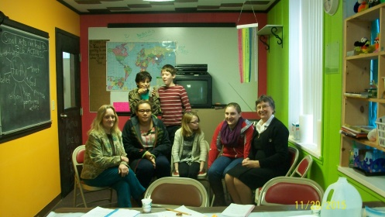
Sunday School is regularly offered for ages four through adult. Classes are led by volunteer adults and assistants. Published Christian Education materials are made available. A youth group for teens meets monthly for worship, projects and outdoor activities. In addition to regular Sunday School during the summer months, youth are invited to partner with youth of other churches for Vacation Bible School.

Several Bible studies are offered at the church on a weekly basis. An active women's group takes on a variety of craft projects for shut-ins and holds devotional sessions for their own strengthening.

A local ecumenical group of church volunteers, including members of the Lowville Baptist Church, has formed a “Loving Lewis County” effort to help those in need. This past year, a number of people's homes were repaired free of charge and several community worship and meal services were held.

Members of the Lowville Baptist Church give time and donations to both the local food pantry and the Christmas Sharing program. The Missions Program is historically strong and local, regional and international missionaries are supported throughout the year.

PASTOR JOB DESCRIPTION

- The pastor will be the spiritual leader of the congregation. He/She will work closely with the church officers, boards, committees and the congregation to assure that the church proceeds in a Godly manner to carry out the church’s Purpose/Vision/Mission and to provide a clear direction for the activities, growth and ministry of the church.

- The pastor will present a well-prepared Biblically-based message of appropriate length that displays sound theology and teaching. This bible message should offer relevant instruction/teaching aimed at providing direct application by the congregation.

- It is expected that the pastor will keep regular office hours during the week so that he/she will be readily available to the congregation. When deviations from the regular office hours are needed, due to vacation, conference attendance, special visitations or other reasons, the revised schedule, if at all possible, should be posted in the Sunday bulletin. The pastor will communicate with the Deacons and the Treasurer regarding vacation time and conferences which he/she will attend.

- The pastor should file any logs or documents, i.e. quarterly reports, mileage, conference requests as requested by the Board of Trustees in the manner and time prescribed.

- The pastor should regularly visit the shut-ins, the sick, the aged, and more frequently, those facing death or in mourning.

- The pastor, working with the Board of Deacons, will serve and administrate the ordinances of the Lord’s Supper and baptism.

- The pastor, with other members of the congregation, will provide for an appropriate funeral service and procedures for recently deceased members of our congregation. The pastor will also officiate at weddings as requested, and in keeping with his/her spiritual determination of the couple’s readiness to enter into Holy Matrimony.

LOWVILLE BAPTIST CHURCH
COMMUNITY SURVEY
CONDUCTED NOVEMBER-DECEMBER 2015

Oral responses gathered from a two-question community survey has helped to identify a number of strengths of Lowville Baptist Church, as well as challenge areas on which to focus. Respondents noted that Lowville Baptist Church, known as a central downtown landmark, is recognized for its leadership in ecumenical involvement, is long associated with children's programming, and is appreciated for its attractive sanctuary, group hall and kitchen facility.

Other comments from the forty-seven business owners and managers interviewed suggested that the Church be more pro-active in promoting services and functions, that it open its building to the community more often, that its members help to create a Welcome Package for newcomers to the community, and that its leaders start a benevolence ministry with other local churches.

The team of interviewers agreed that the survey was time well-spent and steps are being taken to build on our strengths and to implement some of the suggested changes.

